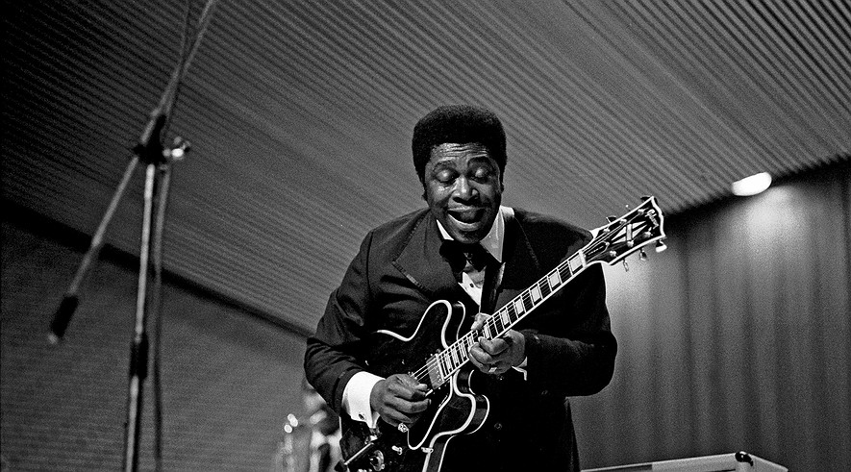

B.B. King, the hugely popular and influential blues guitarist and singer, has died. He was 89.
King died peacefully in his sleep Thursday night in his Las Vegas home.
King was a 15-time Grammy Award winner. His style of guitar playing was imitated by generations of blues and rock musicians.
“B.B. King taps into something universal,” guitarist Eric Clapton told the Los Angeles Times in 2005. “He can’t be confined to any one genre. That’s why I’ve called him a ‘global musician.’”

A Blues Style All His Own
King's unique style made him one of the most respected and influential blues musicians ever. He taught himself how to play guitar. His style developed partly as a way of overcoming two musical shortcomings. Early on, King was unable to play guitar leads while he sang. He was also unable to master the use of the bottleneck, or slide, favored by many other blues guitarists. Slides are made of metal or glass and fit over a guitarist's finger. Players slide them along the strings for cool sounds.
Because King could not figure out how to play lead and sing at the same time, he did the two separately. By doing so, he created what became an all-important element in blues and rock music: the sung verse followed by the solo guitar passage. His approach was copied by generations of players who followed. Everyone from Clapton and Jimi Hendrix on through to John Mayer and the Red Hot Chili Peppers.
King also realized early on that his fingers were too thick to easily work the slides used by so many other blues guitarists. He discovered that he could imitate the sound of a slide by rocking the fingers of his left hand rapidly on the guitar’s frets. The motion created a ringing, wavering sound that became his trademark.

Fans Of All Ages, Genres
King's guitar, a black Gibson hollow-body he called "Lucille," became one of the most famous in all of popular music.
King was a tireless performer who seldom left the concert trail for more than a few days at a time. In 1956 alone he played 342 shows. Even in his later years he kept a schedule that would test the endurance of musicians half his age.
B.B. King worked with hundreds of musicians in most fields of pop and rock music. His 1989 teaming with U2 on the Irish rock band's single “When Love Comes to Town” brought him to the attention of millions of young fans. At the time, he was in his mid-60s.
Rock musicians had helped keep King's career alive many years earlier as well.

Blues Greets The British Invasion
By the 1960s, black audiences had largely moved away from listening to the blues in favor of R&B and soul performers such as James Brown and Ray Charles. King’s record sales began to slip. His career was revived when the Rolling Stones, the Animals, Clapton, Van Morrison and other white rockers of the British Invasion started singing the praises of King and other American blues musicians to their young fans.
The attention from British rockers put King in front of an entirely new audience. After he put out his version of the Lowell Fulson song “The Thrill Is Gone” in 1969, King went to the top of the national sales charts. In 1971, he collected the first of a string of Grammy Awards.

The Music Called
Riley B. King was born on Sept. 16, 1925, on a cotton plantation in Mississippi. He often said that the plantation owner, Johnson Barrett, was a key male role model to him when he was young. It was Barrett who loaned him $30 to buy his first guitar. “My Darling Clementine” was the first song he learned to play. His early influences included jazz guitarists Charlie Christian and Django Reinhardt and blues players such as T-Bone Walker and Lonnie Johnson.
King dropped out of high school at 15 because he discovered he could make more money playing guitar for a night than he got for a full day’s work on the plantation. In 1946, he moved to Memphis, Tennessee, to try his luck as a professional musician.
In Memphis, King became known as “the Blues Boy of Beale Street,” then the Beale Street Blues Boy. This nickname was shortened to Bee Bee, and later simply B.B.
In 1949 a fight broke out between two men in the middle of one of King's concerts. During the fight a lantern was knocked over, setting the barn on fire. King and the others escaped, but he raced back into the blazing structure when he realized he had left his guitar behind. When he found out that the men had been fighting over a woman named Lucille, he gave the name to his guitar “to remind myself never to do anything that foolish,” he said.
That particular guitar was stolen two years later, but he kept the name for every instrument he used onstage after that.

Many Albums Later
King recorded more than 50 albums throughout his career. In 1987 he was inducted into the Rock and Roll Hall of Fame. He received a lifetime achievement award from the National Academy of Recording Arts and Sciences in 1988.
King was married twice. He first married Martha Lee when he was 17, and then Sue Hall when he was 32. Each marriage lasted about eight years. He had 15 children.

