B.B. King, blues legend and "global musician," dies at 89
By Los Angeles Times, adapted by Newsela staff
05.19.15
Grade Level 9Word Count 1,002
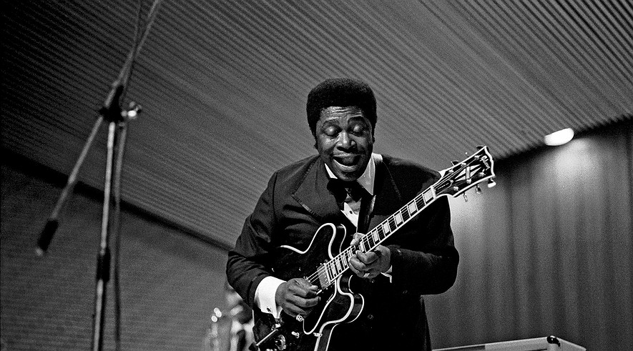B.B. King playing his guitar "Lucille" at a performance in Hamburg, Germany, in November 1971. Photo:Wikimedia Commons

The enormously influential blues guitarist and singer B.B. King has died at the age of 89.
King died peacefully in his sleep Thursday night in his Las Vegas home, a family representative said. He had struggled in recent years with diabetes.
King was a 15-time Grammy Award winner. His signature style was imitated by generations of blues and rock musicians.
“B.B. King taps into something universal,” guitarist Eric Clapton told the Los Angeles Times in 2005. “He can’t be confined to any one genre. That’s why I’ve called him a ‘global musician.’”

Unique Blues Style Is Born
Early on, King created a unique style that made him one of the most respected and influential blues musicians ever. In part, his style developed as a way of overcoming two musical shortcomings: an inability to play guitar leads while he sang and a failure to master the use of the bottleneck, or slide, favored by many other blues guitarists.
Because King could not figure out how to play lead and sing simultaneously, he taught himself to separate the two functions. In doing so, he laid the blueprint for what would become an all-important element in blues as well as in rock music rooted in the blues - the sung verse followed by the extended solo guitar passage. That template was exploited by generations of players who followed, from Clapton and Jimi Hendrix on through to John Mayer and the Red Hot Chili Peppers.
King's fingers were too thick to easily work the beer bottlenecks and metal slides used by so many other blues guitarists. He discovered that he could imitate the sound of a slide by rocking the fingers of his left hand rapidly on the guitar’s frets. The motion created a ringing tremolo that became his hallmark.

With "Lucille" At His Side
King's guitar, a black Gibson hollow-body he called "Lucille," became one of the most famous in all of popular music. It was as central to his public persona as his rotund physique, twinkling eyes and wide-eyed grin, which served as a counterpoint to the soul-deep ache at the heart of much of his music.
King spent decades honing the craft that helped him escape the poverty of the Deep South, where he grew up on a Mississippi plantation, the son of a sharecropper. He became a teenage sharecropper himself before singing and playing his way out of the cotton fields.
King was a tireless performer who seldom left the concert trail for more than a few days at a time. In 1956 he played 342 shows, and even in his later years he kept a schedule that would test the endurance of musicians half his age.
King had a lifelong drive to bring respectability to a form of music disparaged in his youth as “the devil’s music.” It still lacked respect during his adulthood as “the music of the ghetto.”

Rock And Blues Find A Rhythm
King collaborated with hundreds of musicians in most fields of pop music, culminating with his 1989 teaming with U2 on the Irish rock quartet’s single “When Love Comes to Town.” The song brought him to the attention of millions of young rock fans when he was in his mid-60s.
Rock musicians had helped keep King's career alive decades earlier as well. By the 1960s, black audiences had largely moved away from listening to the blues in favor of R&B and soul performers such as James Brown and Ray Charles. King’s flagging career was revived when the Rolling Stones, the Animals, Clapton, Van Morrison and other white rockers of the British Invasion started singing the praises of King and other American blues musicians to their young fans.
The attention put King in front of an entirely new audience. After he put out his version of the Lowell Fulson song “The Thrill Is Gone” in 1969, King went to the upper reaches of the national sales charts and in 1971, collected the first of a string of Grammy Awards.

Riley Becomes B.B.
Riley B. King was born Sept. 16, 1925, on a cotton plantation between Itta Bena and Indianola, Mississippi. He often cited the plantation owner, Johnson Barrett, as one of the key male role models of his youth. It was Barrett who advanced him the $30 to buy his first guitar. “My Darling Clementine” was the first song he learned to play. His early influences included jazz guitarists Charlie Christian and Django Reinhardt, and blues players such as T-Bone Walker and Lonnie Johnson.
King dropped out of high school at 15 because he found he could make more money playing guitar for a night than he got for a full day’s work on the plantation. In 1946, he moved to Memphis, Tennessee, to try his luck as a professional musician.
In Memphis, King became known as “the Blues Boy of Beale Street,” then the Beale Street Blues Boy. This nickname was shortened to Bee Bee, and later simply B.B.
In 1949 a fight broke out between two men in the middle of one of King's concerts. During the fight, a lantern was knocked over, setting the barn on fire. King and the others escaped, but he raced back into the blazing structure when he realized he had left his $30 guitar behind. When he found out that the men had been fighting over a woman named Lucille, he gave the name to his guitar “to remind myself never to do anything that foolish.”
That particular guitar was stolen two years later, but he kept the name for every instrument he used onstage after that.

Lifetime Achievements
King recorded more than 50 albums and was inducted into the Rock and Roll Hall of Fame in 1987 and the Blues Hall of Fame. He received a lifetime achievement award from the National Academy of Recording Arts and Sciences in 1988.
King was married twice — to Martha Lee when he was 17 and then Sue Hall when he was 32. Each marriage lasted about eight years. He had 15 children.

