B.B. King, great blues guitarist who inspired many musicians, dies at 89
By Los Angeles Times, adapted by Newsela staff
05.19.15
Grade Level 6Word Count 793
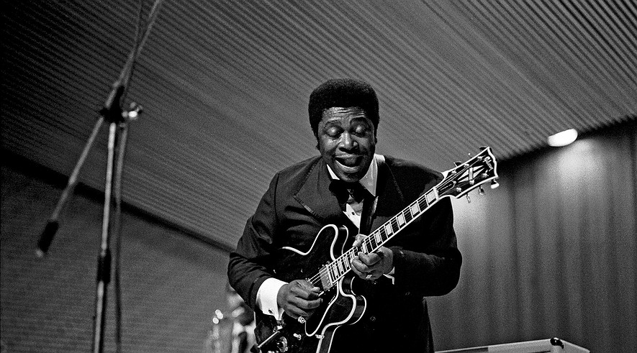B.B. King playing his guitar "Lucille" at a performance in Hamburg, Germany, in November 1971. Photo:Wikimedia Commons

B.B. King, the famous blues guitarist and singer, has died. He was 89.
His family said he died peacefully in his sleep Thursday night in his Las Vegas home.
King was a 15-time Grammy Award winner. His playing was imitated by generations of blues and rock musicians.
“B.B. King taps into something universal,” guitarist Eric Clapton said in 2005. “He can’t be confined to any one genre. That’s why I’ve called him a ‘global musician.’”

His Own Sound Was Copied By Many
King's unusual guitar style made him one of the most respected and imitated blues musicians ever. His style developed partly as a way to get around two things he could not do.
Early on, King was unable to play guitar leads while he sang. He also could not master the use of the slide favored by many other blues guitarists. Slides are made of metal or glass and fit over a guitarist's finger. Players slide them along the strings to make cool sounds.
Because King could not figure out how to play lead and sing together, he did them separately. He would sing a few lines, then play a guitar solo, then sing a few more lines. His approach was copied by generations of blues and rock players who followed. Everyone from Clapton and Jimi Hendrix on through to John Mayer and the Red Hot Chili Peppers did it.
King also realized that his fingers were too thick to easily use a slide. He discovered that he could imitate the sound of a slide by rocking the fingers of his left hand rapidly on the guitar’s frets. The motion created a ringing, wavering sound that became his trademark.

When Blues Meets Rock Music
King was a tireless performer who seldom stopped giving concerts for more than a few days at a time. In 1956 alone he played 342 shows. Even as he got much older he kept up a touring schedule that would be hard for musicians half his age.
King worked with hundreds of musicians in most fields of pop music. In 1989, he teamed up with the Irish rock band U2 on the single “When Love Comes to Town.” The song brought King, who was 66 at the time, to the attention of millions of young rock fans.
Rock musicians had helped keep King's career alive many years earlier as well.
By the 1960s, black audiences were no longer much interested in listening to the blues and B.B. King’s record sales began to slip.
His career was revived when British rock musicians discovered the blues. The Rolling Stones, the Animals, Clapton, Van Morrison and others began telling their young fans how great King was.
The attention from British rockers put King in front of an entirely new audience. King's career really took off after he released “The Thrill Is Gone” in 1969, and in 1971, he collected the first of a string of Grammy Awards.

Blues Boy Riley Is B.B.
Riley B. King was born in Mississippi on Sept. 16, 1925. As a youngster he worked on a cotton plantation. He often said how the plantation owner had loaned him $30 to buy his first guitar. “My Darling Clementine” was the first song he learned to play.
King dropped out of high school at 15. By then, he discovered he could make more money playing guitar for a night than he got for a full day’s work on the plantation. In 1946, he moved to Memphis, Tennessee, to try his luck as a professional musician.
In Memphis, King became known as “the Blues Boy of Beale Street,” then the Beale Street Blues Boy. This nickname was shortened to Bee Bee, and later simply B.B.

Special Place In The Hall Of Fame
In 1949, a fight broke out between two men in the middle of one of King's concerts. During the fight a lantern was knocked over, setting the barn on fire. Everyone escaped, but King raced back into the blazing structure when he realized he had left his guitar behind. When he found out that the men had been fighting over a woman named Lucille, he gave the name to his guitar “to remind myself never to do anything that foolish,” he said.
King's guitar was stolen two years later, but he kept the name for every instrument he owned after that.
B.B. King recorded more than 50 albums throughout his career. He once said he had lost count of how many records he made. In 1987, he was voted into the Rock and Roll Hall of Fame. He received many other musical awards.
King was married twice — first to Martha Lee when he was 17, and then to Sue Hall when he was 32. He had 15 children.

